430 W. WHEAT ROAD, VINELAND, NJ 08360 PHONE: 856-696-0917 FAX: 856-696-6990
WEBSITE: stanthonyvinelandnj.com EMAIL: contactus@stanthonyvinelandnj.com
COMMUNITY CENTER RENTAL INQUIRIES: 856-794-5155 EMAIL: stanthony.communitycenter@gmail.com

HIS EMINENCE METROPOLITAN EVANGLEOS of NEW JERSEY
REV. FR. ANASTASIOS BOURANTAS, Vicar of Delaware Valley Region 484-716-8276
Volume 4 Edition 2019
NEWSLETTER for DECEMBER 2019-JANUARY 2020
CHRISTMAS MESSAGE: 2019

Christianity once again celebrates the Nativity of Jesus Christ according to the flesh. The festive atmosphere of the season saturates our homes with Christmas melodies, the tantalizing aroma of baked goods, radiantly bright decorations honoring this blessed occasion and, of course, the Christmas gifts. Ultimately, the focus is our family and friends gathering around the table at Christmas as we enjoy the holiday celebration together. All these wonderful delights come together to create a magical atmosphere on this major Christian holiday.

The Christmas story begins with a cold and dingy stable in Bethlehem, the visitation of the simple, yet kind-hearted local shepherds, the resplendent angelic hymns and the dazzling star in the East that guides the Maggi to the sacred manger so they may worship the King of Kings. What a panoramic sight! This entire scene inspires our hearts with love and reassures us with a sense of peace that we have never before felt.

BUT ONE MIGHT ASK, WHY WASN’T THE CHRIST BORN LIKE EVERYONE ELSE?

After Christ’s Resurrection, the apostles interviewed St. Mary to understand the full details of the Savior’s birth. While carefully listening to the nativity narrative, they perceived the deeper, underlying meaning of the Christmas Story. They understood that Christ’s arrival to the world summoned the Creation of a New Humanity. After the original Adam failed, God became more determined to succeed. He sent His only-begotten Son. God birthed Jesus Christ, the Second Adam, with the collaboration of the purity of St. Mary. God transfigured the world by creating the New World of Jesus Christ. He established the “new creation” with a defining axis centered on love, freedom and justice.

Christ’s dramatic appearance in the world allowed God’s Will to directly challenge each of us. Fatalism and desolation were everywhere. Life seemed hopeless and discouraging. Christ’s dynamic presence changed the entire flow of history by offering mankind the new creation: a world based on love. God’s intervention encouraged us with optimism and the ability to succeed.

Christ arrived in a hostile environment: the foul smelling barn, the forced refugee status in Egypt and ultimately His death on the Cross. His countrymen overlooked Him. Even His own nation was bleak and inhospitable. Christ never took his eyes off of His providence to offer life to the world.

Again, this year you are invited, as a parish community, to celebrate the incredible story of Christmas. Christ came to us out of God’s love for all of mankind. We know very well that the world can be a lonely and cruel place, but God’s love sustains and comforts each of us. To participate, we need to embrace Jesus with gladness and extend to Him our own love. Let us attend Church and rededicate ourselves to Christ and to His parish under the patronage of St. Anthony.

A MERRY CHRISTMAS TO ALL!
Rev. Fr. Emmanuel Pratsinaki
Holy Liturgies at St. Anthony: Orthos 9 a.m., Liturgy 10:00 a.m
Every Sunday
Nov 21, The entrance of the Theotokos into the temple
Dec 24, The Nativity of our Lord and Savior Jesus Christ, Orthos 8p.m, H.L 9 p.m.
Jan 1, Circumcision of our Lord and Savior Jesus Christ, St. Basil the Great
Jan 5.
Jan 6, The Theophany of our Lord and Savior Jesus Christ.
Jan 7, The Synaxis of John the Holy Glorious Prophet, Baptist and Forerunner.
Jan 16, Vespers for St. Anthony the Great.
Jan 17, St. Anthony the Great.
Jan 30, Synaxis of the Three Hierarchs: Basil the Great, Gregory the Theologian and John the Chrysostom

Θεία Λειτουργία στόν Αγιο Αντώνιο, Ορθρος 9 π.μ. θ.Λειτ.10.305π.μ.
Κάθε Κυριακή
21 Νοεμβρίου,Τά Εισόδια Τής Θεοτόκου
24 Δεκεμβρίου(βράδυ)Η Γέννησης τού Κυρίου ημών Ιησού Χριστού ορθρος8.μ.μ, Λειτ.9.μ.μ
1 Ιαν.Περιτομή τού Χριστού,Τού Αγίου Βασιλείου τού Μεγάλου.
6 Ιαν.Τά Αγια Θεοφάνεια τού Κυρίου ημών Ιησού Χριστού
7 Ιαν.Σύναξις τού Αγίου Ιωάννου τού Προδρόμου.
16 Ιαν.Εσπερινός Αγίου Αντωνίου τού Μεγάλου
17 Ιαν.Αγίου Αντωνίου τού Μεγάλου
30 Ιαν.Τών Αγίων Τρειών Ιεραρχών

Stewardship
Stewardship in the Orthodox Faith is to live and practice the teachings of Jesus Christ and the actions in our daily lives confirm our beliefs in our faith. The Greek Orthodox Archdiocese refers to the three T's of stewardship being Time, Talents and Treasures to the glory of God.
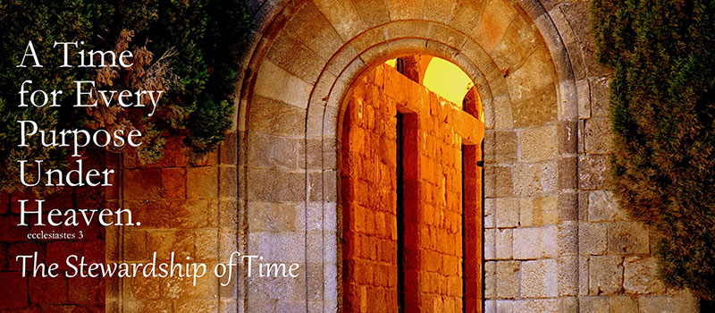
Ordinary Stewardship is the regular practice of returning to God a portion of all that God has given us. It involves teaching ourselves how to create a life built upon the notion that all that we have is a gift from God. This includes spreading the teachings of Christ and the concept that giving regularly of our time, talent, and money to God's work on this earth is as much a spiritual practice as prayer and worship.
Time and Talents is getting involved with the Church both in your participation in ministries and offering your volunteer time as well as your talents to help further the Church's mission and ministries.
Extraordinary Stewardship involves the special occasions that arise in the life of our community that call us to give beyond our ordinary habit. They involve increased risk and encourage us to experiment with sacrificial giving in order to help the community realize critical and important goals and programs. The best example of extraordinary stewardship is our capital campaigns.
Legacy Stewardship is the way in which we address the matter of disposing of the accumulations of our lifetime. It is the opportunity to provide a planned gift that constitutes both a legacy to generations yet unborn and a final testimony of the belief in our Orthodox faith.

Stewardship Update:
2018 2019
(January1 - December 31, 2018) (January 1- December 10, 2019)
# YTD paid Stewards: 75 # YTD paid Stewards: 99 families
Stewardship Income YTD: $37,235.00 Stewardship Income YTD: $ 60,092.00
**We will provide a list of 2019 Stewards in the next edition.

*We accept credit card payments for your convenience.
Please see Raphael or Angela should you prefer to pay your stewardship using this feature.
Any questions regarding 2019 Stewardship please see Nicos Mallouris, Stewardship Chairperson.

Sacraments
40 Day Blessings:
Congratulations on the 40-day blessing of Emmanuel Papamihakalis
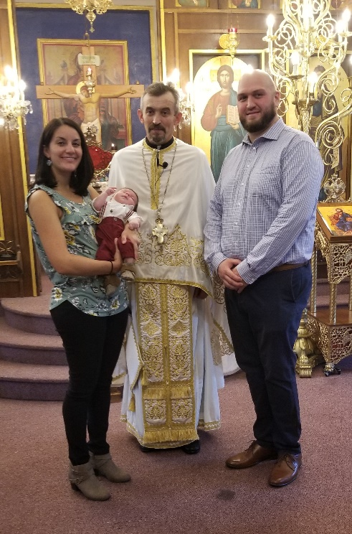
On October 6, 2019. His parents are Sara Munsick
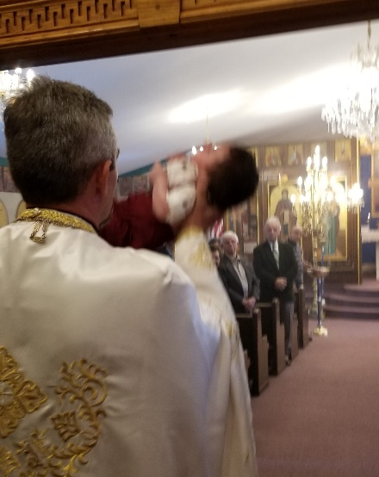
& Jimmy Papamihalakis. Proud
grandparents Emmanuel & Yota
Papamihalakis.
Fr. Constantine Florin presided.

Weddings:
Congratulations to Je nnifer & Tim Ashiotes
on the recent marriage on October 12, 2019.
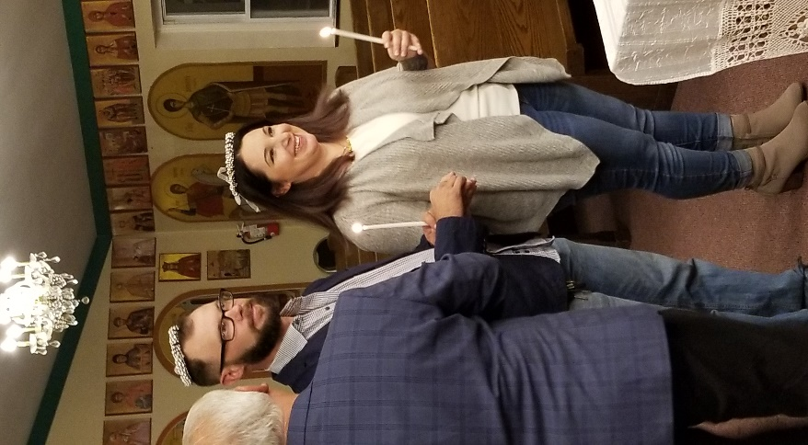
Fr. Anastasios Bourantes officiated.
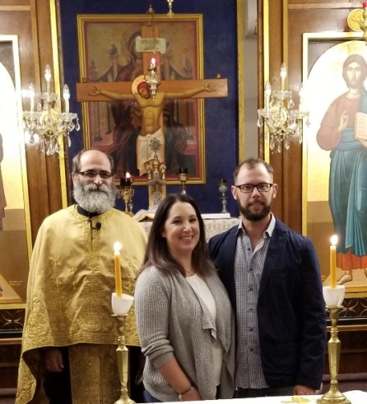

SYMPATHIES AND CONDOLENCES
Memorials:
Fr. Paul N. Pantelis
Father Paul N Pantelis, passed away Wednesday, December 4th at Lahey Clinic with his loving family by his side. Paul Nicholas Pantelis was born in Millville, NJ on May 29 1938, to the parents of Petros and Ourania (Koronakis) Pantelis. He attended grade school and high school in Millville and college at Drexel University in the Engineering program. He was working as a programmer/computer operator at Owens-Illinois when he was drafted into the Army in 1964. After completing Officer Candidate School he was deployed to Vietnam, where he served as a combat engineer for two years. He served with distinction earning the Bronze Star and Purple Heart. After returning home from the war, he remained active in the Army, finally being discharged in October 1977. Shortly thereafter, he met and married his wife Katina and quickly began a family. In 1984 he felt the calling to join the priesthood, and enrolled at Holy Cross Greek Orthodox School of Theology (Brookline MA), graduating in 1987. In 1988, he was ordained a Deacon at St. Demetrios, Wildwood NJ, and into the priesthood at St. George Cathedral, Philadelphia PA. He served parishes in Lowell MA (Holy Trinity), Bangor ME (St. George), Andover MA (Sts. Constantine & Helen), and Norwich CT (Holy Trinity). In 2014, Father Paul retired from the priesthood after 28 years, retiring to Andover MA. In his retirement, he enjoyed going to church, visiting his family and friends, reading the Bible, and staying active on current events.
He is survived by his ever faithful and devoted wife of forty-one years, Presbytera Katina (Kostoulas) Pantelis, two children Christina Royer and husband Michael, Petros Pantelis and his wife Danielle and five grandchildren Rebecca and Paul Royer, Luke, Samuel and Sophia Pantelis; a sister, Eleanor Hamilothoris; and several nieces, nephews and cousins.
Memorial donations may be made in his memory to the St. Anthony’s, Vineland, NJ. Funeral arrangements under the direction of M.R. LAURIN FUNERAL HOME, directors, Louis M. Fazio III, M. Richard Laurin, and Scott Laurin.
For condolences or directions, please go to www.laurinfuneralhome.com

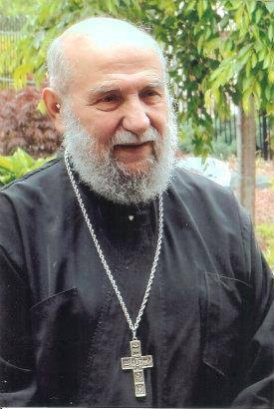

May his memory
be eternal.

Information on Sacraments:
Weddings, Baptisms, Funerals, House Blessings and pastoral visits:
*Please call the church office or contact Angela Papadopoulos-Gilmour to coordinate with Fr. Anastasios Bourantas, Vicar of the Delaware Valley Region regarding sacraments. He will be providing a schedule to meet your request(s).

Memorials: Please contact Gianoula Dinos to arrange koliva and reception after church services.

A Message from the Interim Parish Council President, Nicos Mallouris,

We wish you all Merry Christmas and blessed New Year full of health and happiness .
Starting the new year in January we celebrate our Saint Anthony the Great . We invite you all to join us .
Jan. 16 Holly Vespers 7 pm. Follow mezedakia at our community center .
Jan.17 Holly Litourgy , Orthros 8:30 am, H.Lit. 10:00, follow lunch at the basement of the church .
Jan.18 46th Annual Name Dinner Dance
We invite and welcome you all for special dinner, excellent music and dancing .
For Info and tickets call:
Eric Isihos (609) 774 0471 Nicos Mallouris(856) 495 3006, Angela Papadopoulos (609) 501 1875
From the Parish Council of St. Anthony, Vineland NJ

Ευχομαστε σέ ολους Καλά Χριστούγεννα καί ευλογημένα, ευτυχισμένος ο καινούργιος χρόνος γεμάτος υγεία καί χαρά.
Μέ τήν αφιξη τού νέου ετους γιορτάζουμε τόν πολιούχο μας Αγιο Αντωνιο τόν Μέγα.
Σάς παρακαλούμε νά συμμετάσχετε σέ ολες τίς ιερές ακολουθείες πρός τιμή του καί δικό μας πνευματικό οφελος.
16 Ιαν.7μμ Μεγας Εσπερινός, μετά στο Χώλ μας γιά μεζεδάκια
17 Ιαν. 8.30 ορθρος, 10.00 Θεία Λειτουργία, μετά προσφέρεται γεύμα στό υπόγειο τής εκκλησίας μας.
18 Ιαν. 46^{η} ετήσια χοροεσπερίδα . Μια λαμπρή βραδυά μέ εξαιρετικό φαγητό καί καταπληκτική μουσική καί πατροπαραδοτους χορούς .Σας προσκαλούμε ολους γιά μιά υπεροχη καί αξέχαστη βραδυά
Γιά εισητήρια καί πληροφορίες τηλαφωνήστε
Ηρακλής Ησυχος (609) 774 0471, Νικος Μαλλουρης (856) 495 3006, Α. Παπαδόπουλος (609) 501 1875
Εκ τού Συμβουλιου τού Αγίου Αντωνίου, Βαινλαντ,Νέας Ιερσέης

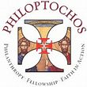
LADIES OF PHILOPTOCOS, CHAPTER 1009
We have been very busy. Many have been baking cookie trays, which are for sale. $25.00 a tray. We also have Vasilopita for sale, $15.00. (See Gianoula Dinos to place your orders.)
One of our missions is to feed the poor. Together with Project Thanksgiving, (see photos in this issue) we helped with collecting turkeys and more. These turkeys went to the Food Banks. Our Chapter donated 21 turkeys. We also provided Mylar blankets to Miss Vineland for the homeless to stay warm this winter. In additions, we presented Alex Kaganzev with the special tray collection for Project Thanksgiving to assist in purchasing additional turkeys to feed the poor and veterans.
We also collaborated with Truth & Spirit Ministries and provide them with canned goods and dry goods collected from our parishioners’ and those from Project Thanksgiving.to feed the homeless that come to their location during the Thanksgiving holiday.
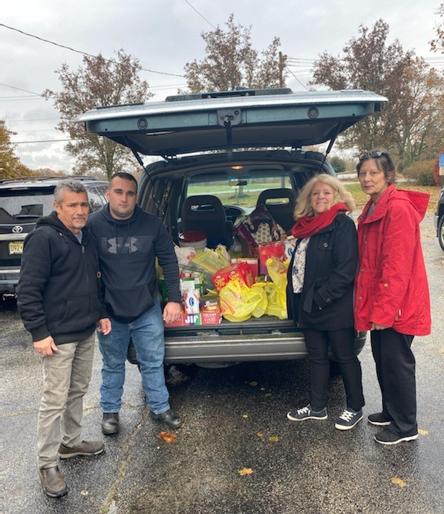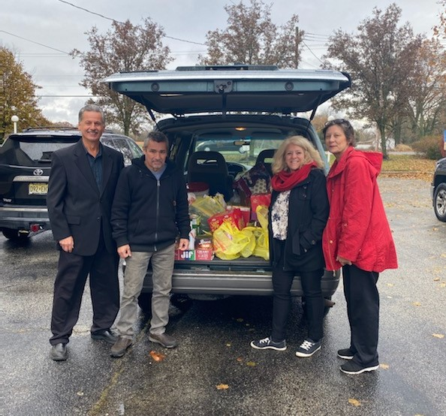

Truth & Spirit Ministries informed us that they are in great need of winter
hats, scarves, gloves and socks for men, woman and children. We are collecting donations for Christmas.
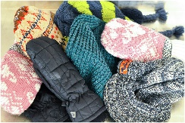
Please see Angela, Gianoula or Marina
if you wish to provide monetary donation.

We wish everyone a Happy & Healthy Christmas & New Year.
Angela Papadopoulos-Gilmour
President, Chapter 1009
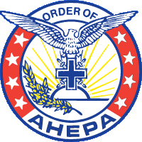
AHEPA Chapter #162

Merry Christmas & a Happy New Year to all.
Panagoitis Doulis, President

GREAT THINGS ARE HAPPENING AT ST. ANTHONY’s!

HELLENIC/GREEK CULTURE SCHOOL:
Greek School teacher, Spiridoula Gerakios, taught the students about Oxi Day. The students presented a short program on October 27, 2019.
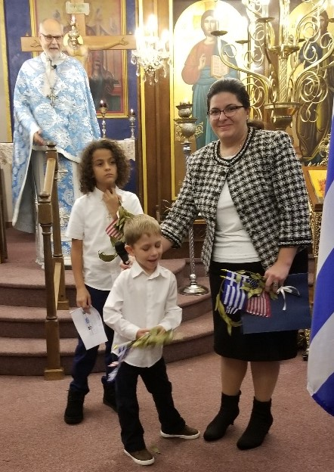
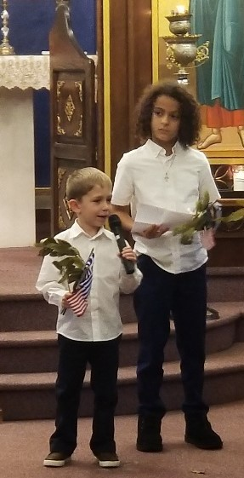

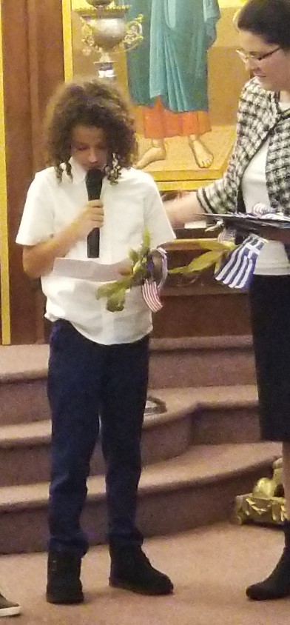

SOME HIGHLIGHTS from the last few months….

Congratulations to years’ Ambassador Award winners!
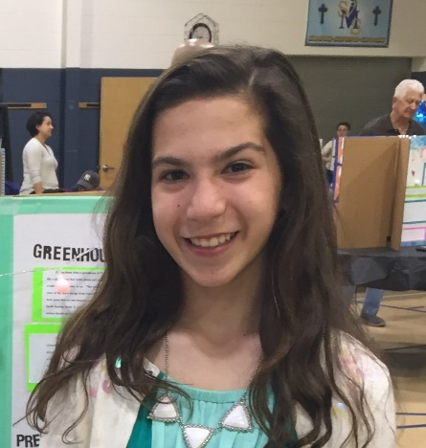
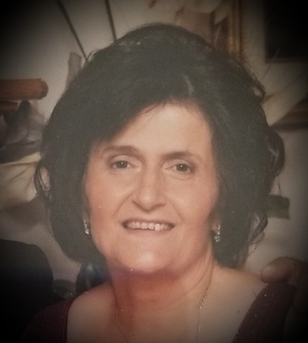
November 10, 2019
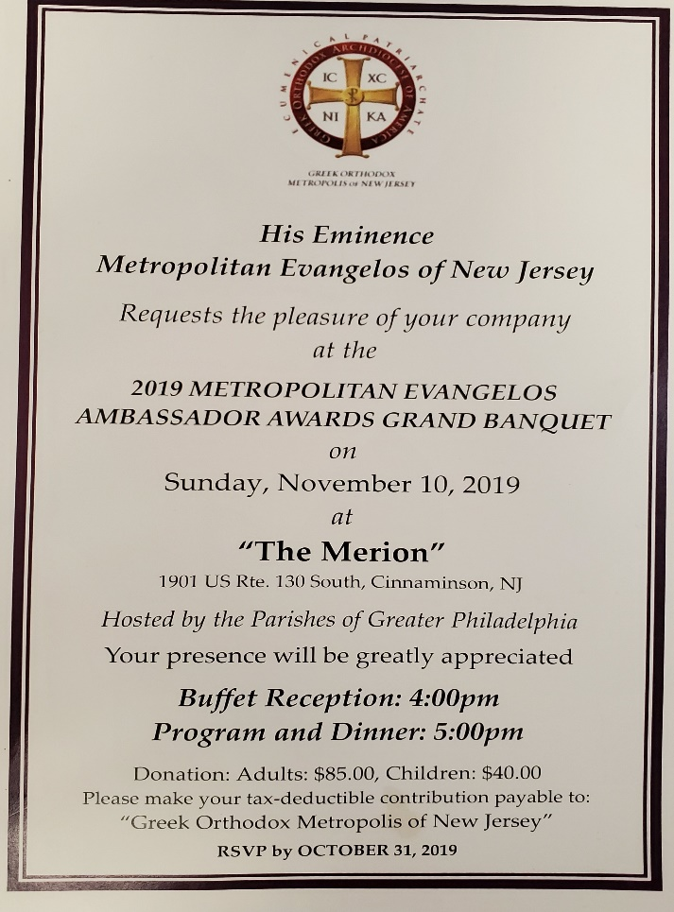

Antonia Mertis Marina Christianis
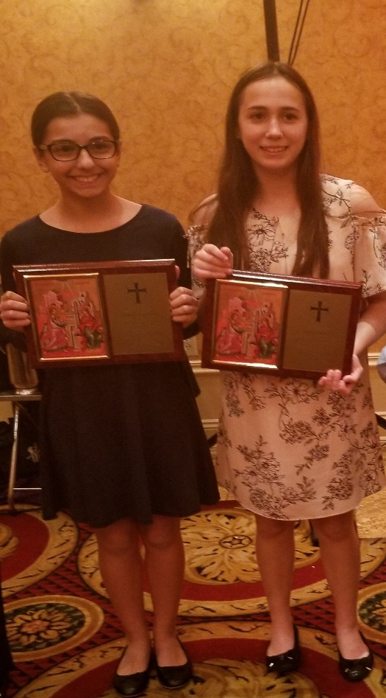
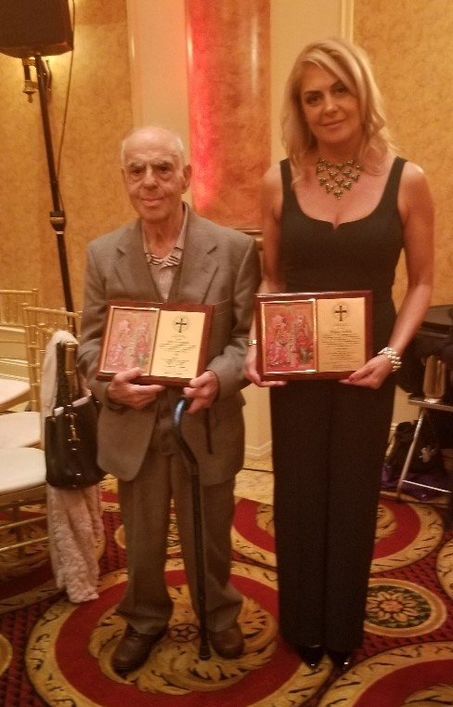

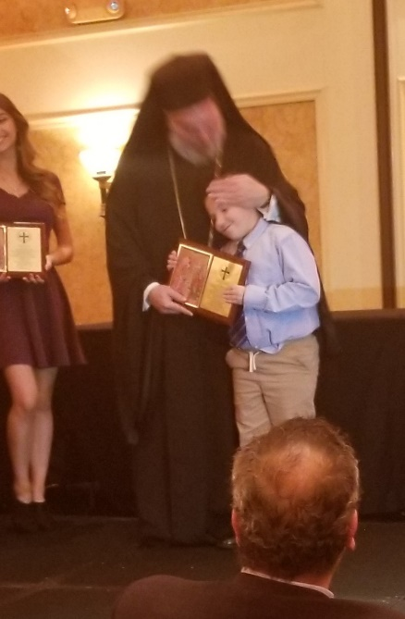

John Frangakis
Poppy Isihos Hariklia Kastrounis
Rebecca Royer
Paul Royer
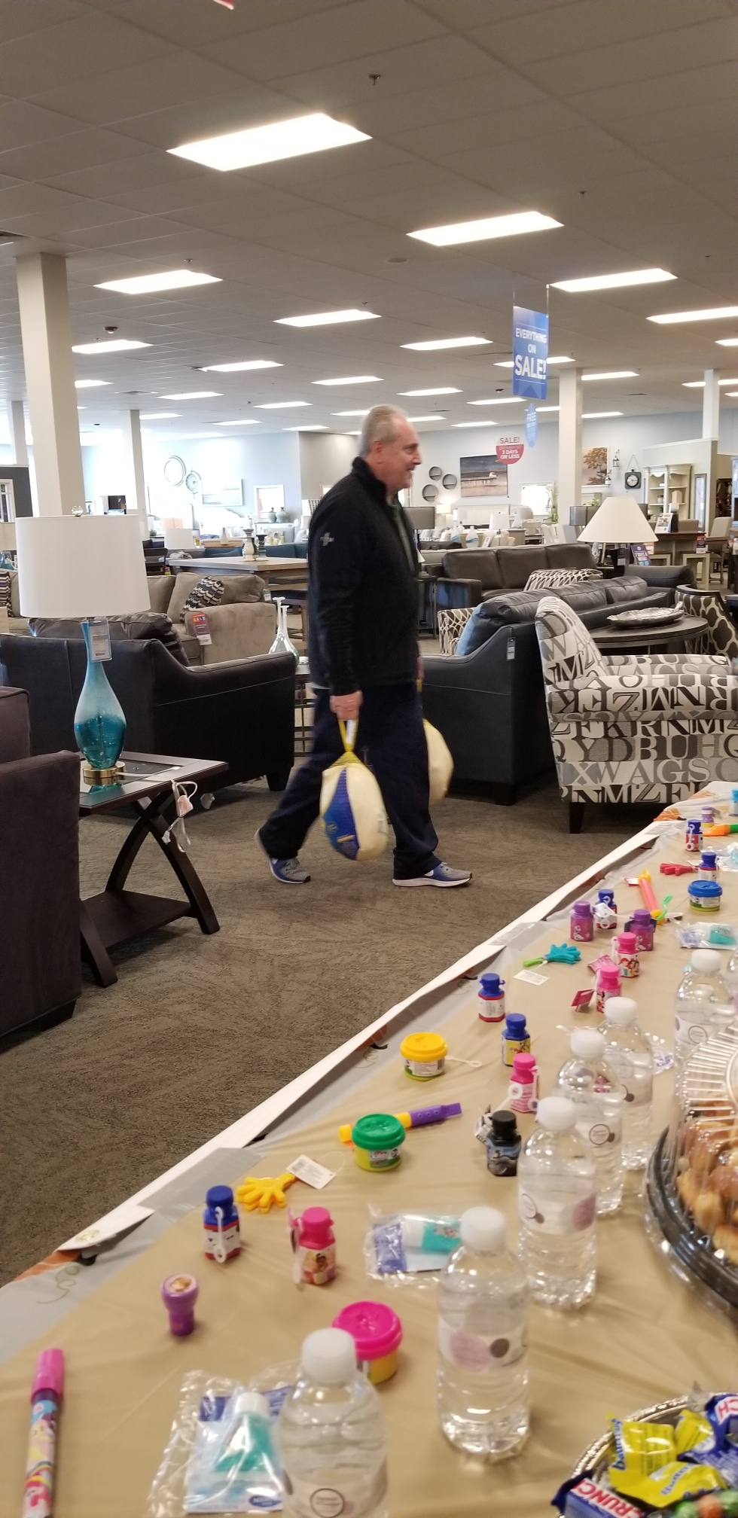

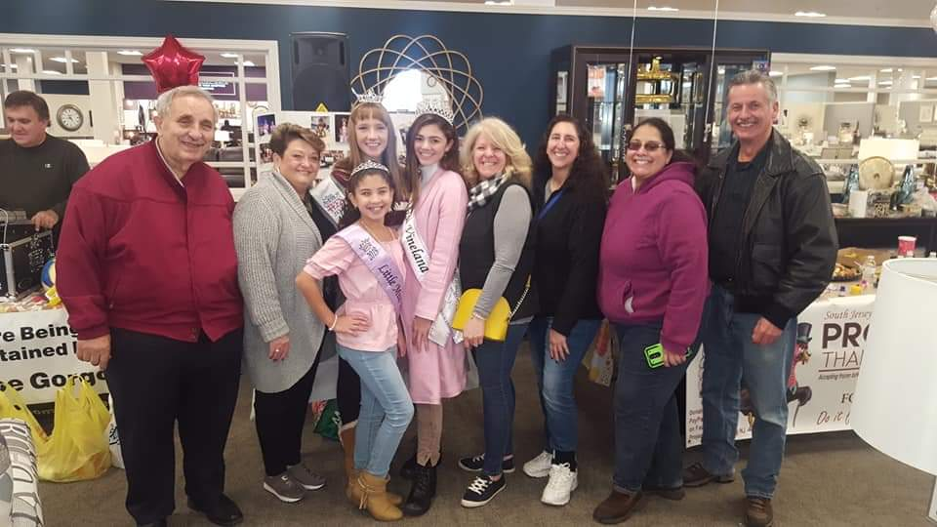
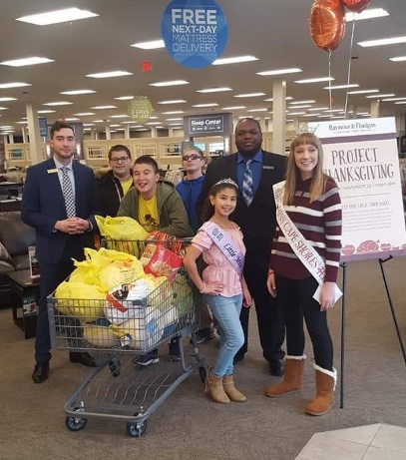
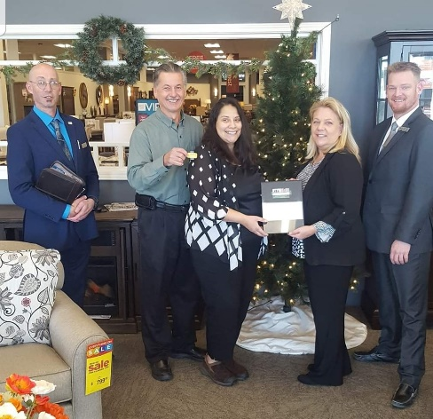

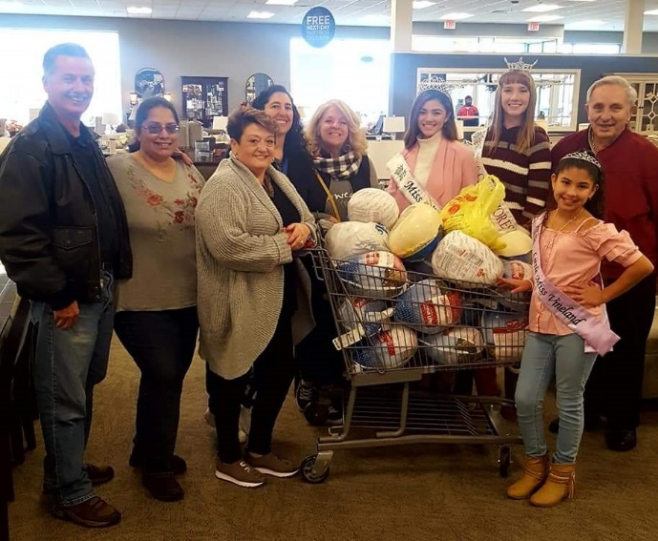
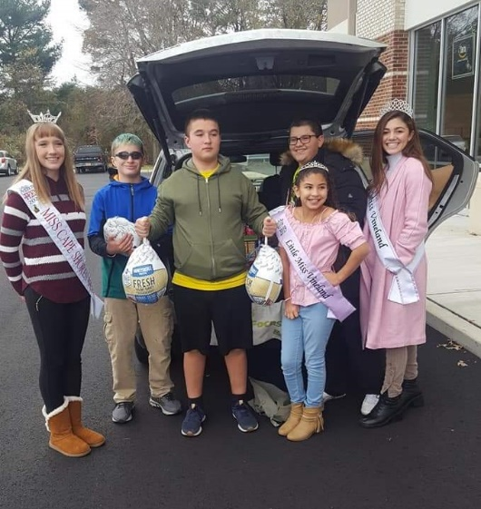

The Philoptochos had a great time participating in Project Thanksgiving. We collected approximately 40 turkeys, food, blankets and donations. We even had a few surprise helpers show up!
Upcoming events:
KALANDA SCHEDULE
First Weekend
Fridy, Dec 13th Vineland: Homes and businesses located between Rt.55 and Main Rd. (5-10 pm)
Saturday, Dec 14th Vineland: Homes and businesses located between Main Rd. and Lincoln Ave.
Sunday, Dec 15th Vineland: All homes and businesses (east of Lincoln Ave) and Buena. (2-8 pm.)
Also Millville-Dorchester-Port Norris-Cedarville (6-9 pm)

Second Weekend
Friday, Dec 20th Newfield-Malaga-Franklinville-Pittsgrove-Rosenhayn-Elmer-Monroeville-Woodstown- Bridgeton (5-10 pm)
Saturday, Dec 21st Clayton-Pitman-Glassboro-Mullica Hill-Woodbury Hts-Deptford (2-9pm)
Sunday, Dec 22nd Milmay , Dorothy, Mays Landing , Egg Harbor, Hammonton, Williamstown,
Washington Twp. (2-9 pm)
-------------------------------------------------------------------------------------------------------------------
ΠΡΟΓΡΑΜΜΑ ΚΑΛΑΝΤΩΝ 2019
Πρωτη εβδομαδα
Παρασκευη 13 Δεκ. Βαινλαντ. Περιοχη μεταξυ Εθνικης Οδου 55 και την Μειν Ροαντ (5-10 μμ)
Σαββατο 14 Δεκ. Βαινλαντ.Περιοχη μεταξυ Μειν Ροαντ και Λινκολν .
Κυριακη 15 Δεκ. Βαινλαντ. Ολη η περιοχη ανατολικα της Λινκολν, και Μπιουνα (2-8 μμ)
Επισης περιοχες Μιλλβιλ , Ντορτσεστερ,Πορτ Νορρις,Σινταρβιλ (6-9 μμ)

Δευτερη εβδομαδα
Παρασκευη 20 Δεκ. Περιοχες.Νιουφιλντ,Μαλαγα,Φρανκλινβιλ,Πιτσγκροβ,Ροσενχειν,Ελμερ,Μονροεβιλ,
Γουντσταουν, Μπριτζτον, (5-10μμ)
Σαββατο 21 Δεκ. Περιοχες.Κλεητον,Πιτμαν,Γκλασμπορο,Μολικα Χιλ,Γουντμπερυ,Ντεπφορντ (2-9μμ)
Κυριακη 22 Δεκ. Μιλμει, Ντοροθι,Μεις Λαντινγκ,Εγγ Χαρμπορ, Χαμμοντον, Ουιλιαμσταουν, Ουασινγκτον Ταουνσιπ, (2-9 μμ)

Pan Kaskabas, Kalanda Coordinator 609-517-7691 C, 856-696-3650 W, 856-692-4012 H.
Renting Our Community Center:
Contact Poppy Isihos if you or
someone you know is interested
in booking our hall.
She can be reached at 856.794.1555
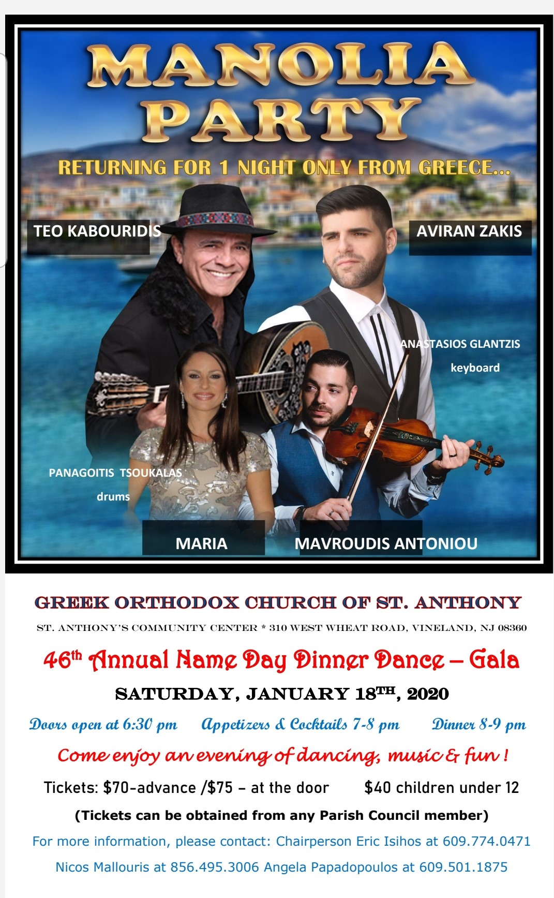

SUNDAY SCHOOL:
Teachers are needed.
Become a Sunday School teacher.
Help teach our youth about the Gospel and what it means to be Greek Orthodox Christians.
Our Sunday School which will be conducted every Sunday immediately after our children receive Holy Communion will give our children and youth the opportunity to learn about our Orthodox faith and practices.
Don’t miss this unique opportunity to become knowledgeable about the teachings, rules and regulations we Orthodox Christians are to live by and maintain for our religious lives.
We need your help.
Thank you corner:
*Community Center was recently painted during the Thanksgiving holiday. Thank you to Spartan Painting Co. Stavros Markakis & George Frangomihalos whom did an excellent job painting and to the donors that provided the paint.
****Submission deadline for December/January Newsletter:****
February 10, 2020
Please submit to Angela Papadopoulos-Gilmour, Managing Editor
Editorial Staff: Fr. Anastasios Bourantes, Vicar of Delaware Valley Region

MONTHLY Meetings:
1st Monday each month the Ladies of Philoptochos meet at 6pm in the church basement.
2nd Wednesday of the month, the Parish Council meets at 7 pm in the church basement.
2nd & 4th Wednesdays of the month, the AHEPA meets at 7 pm in the AHEPA ROOM at the Community Center.

SPECIAL MEETINGS:
*Name Day Dance Committee:
Eric Isihos, Chairperson

Orthodox Church of St. Anthony
430 West Wheat Road
Vineland, New Jersey 08360

